**Supplementary Material**

Supporting information to the manuscript:

**Bayesian identification of a single tracer source in an urban-like environment using a deterministic approach**

Fei Xue1, Xiaofeng Li*,1,2 Weirong Zhang3

1 Department of Building Science, School of Architecture, Tsinghua University, Beijing, China

2 Beijing Key Lab of Indoor Air Quality Evaluation and Control, Beijing 100084, China

3 Department of Architecture, Tokyo Polytechnic University, Japan

Email address: [xue-f13@mails.tsinghua.edu.cn](mailto:xue-f13@mails.tsinghua.edu.cn), [xfli@tsinghua.edu.cn](mailto:xfli@tsinghua.edu.cn)

**Contents of this file**

1. Text S1
2. Figures S1 to S2

**S1. Sensitivity analysis of the standard deviation of noise $σ_{i}$**

In the Bayesian inference, the standard deviation of noise $σ_{i}$ is a key parameter in the likelihood function Eq. (3). It includes both measurement errors in the concentration observations and model errors in the dispersion model used to provide the predicted concentrations. Generally, these errors are difficult to determine. In this paper, $σ_{i}$ is assumed to be equal to the standard deviation of the measurement at the *i*-th sensor. However, this is only an estimation that crudely considers that the errors are of the same magnitude as the turbulent fluctuation of the tracer. Therefore, a sensitivity analysis of $σ_{i}$ on the estimation results is performed.

The Bayesian inference follows the same method in Section 5.2, except for the values of $σ_{i}$, which are set proportionally to the standard deviation of the measurement with a constant scale factor *λ*, as follows:

|  |  |  |
| --- | --- | --- |
|  | $$σ_{i}=λσ_{obs,i}$$ | (S.1) |

where $σ_{obs,i}$ is the standard deviation of the observed concentrations at the *i*-th sensor. Here, *λ* is set ranging from 0.2 to 2.0 to run the sensitivity analysis. The results of Cases 1 and 2 are summarized in Figs. S.1 and S.2, respectively. It should be noted that the value of *λ* used in the manuscript was 1.0.

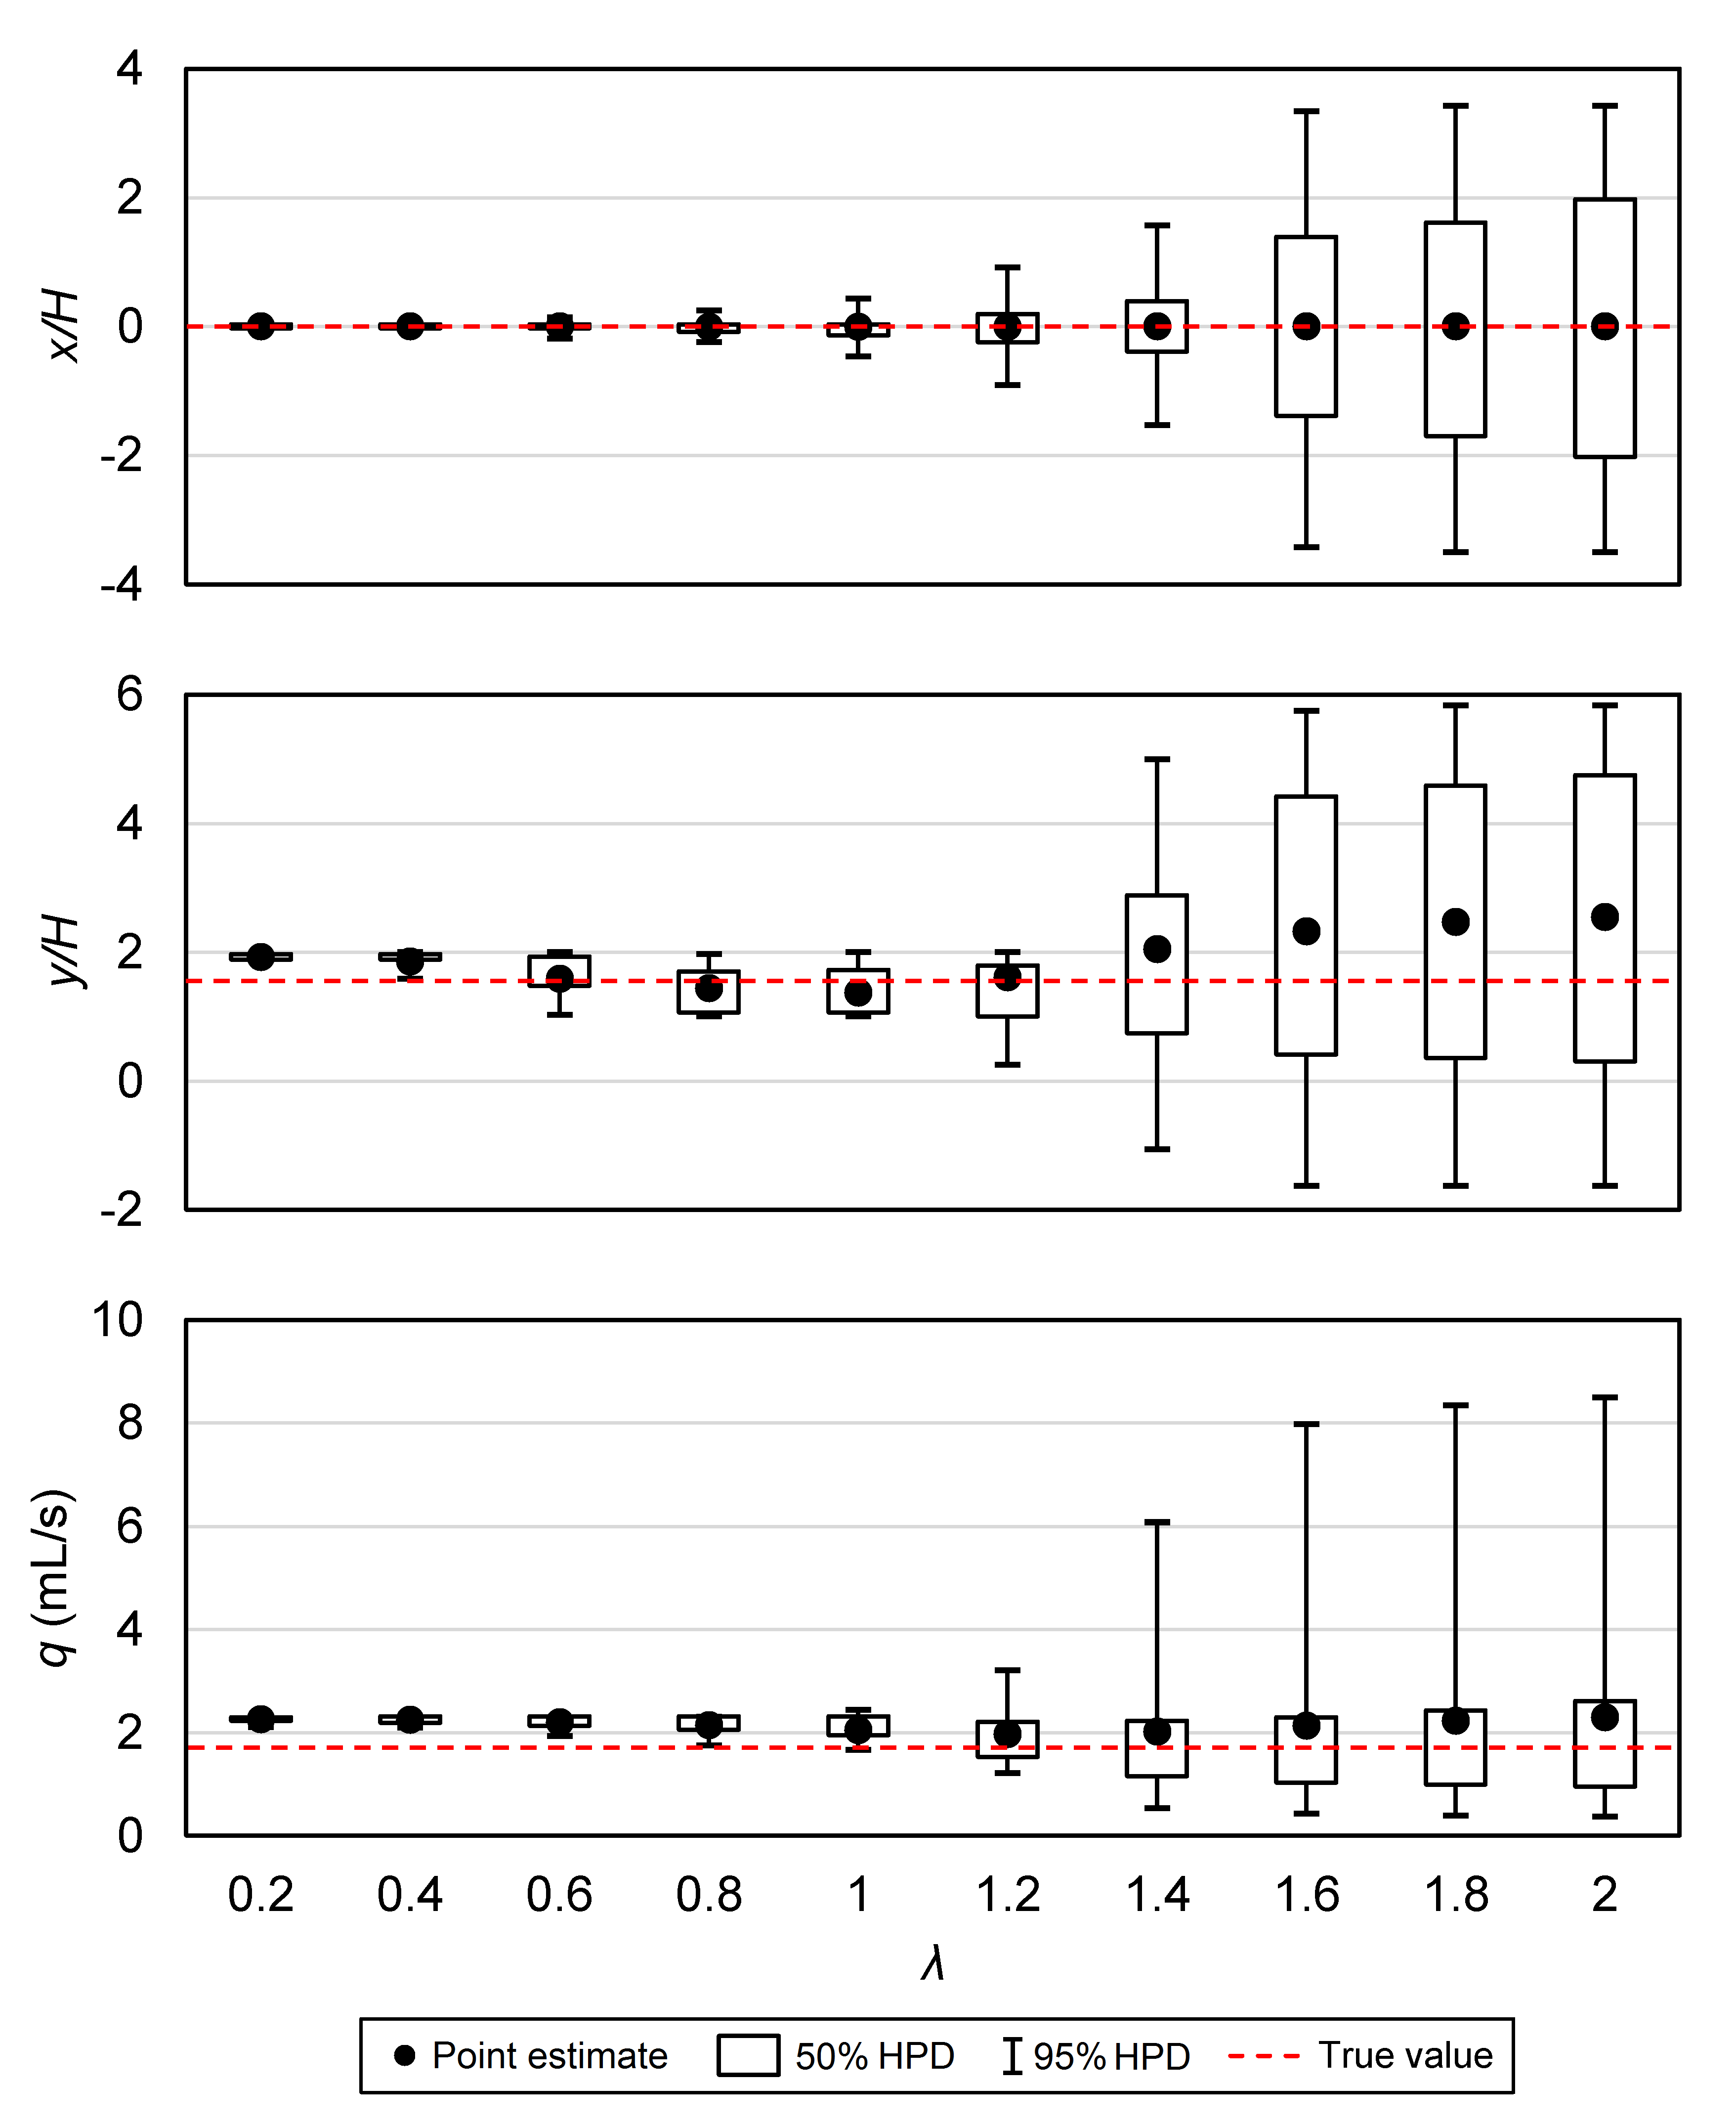

Fig. S1. Estimation results of source location (*x*- and *y*-coordinates)and emission strength *q* (mL/s) with different *λ* values in Case 1. Points denote the point estimates, i.e., posterior mean values, with boxes and whiskers representing the 50% and 95% highest posterior density intervals, respectively. True values are indicated by dashed lines.

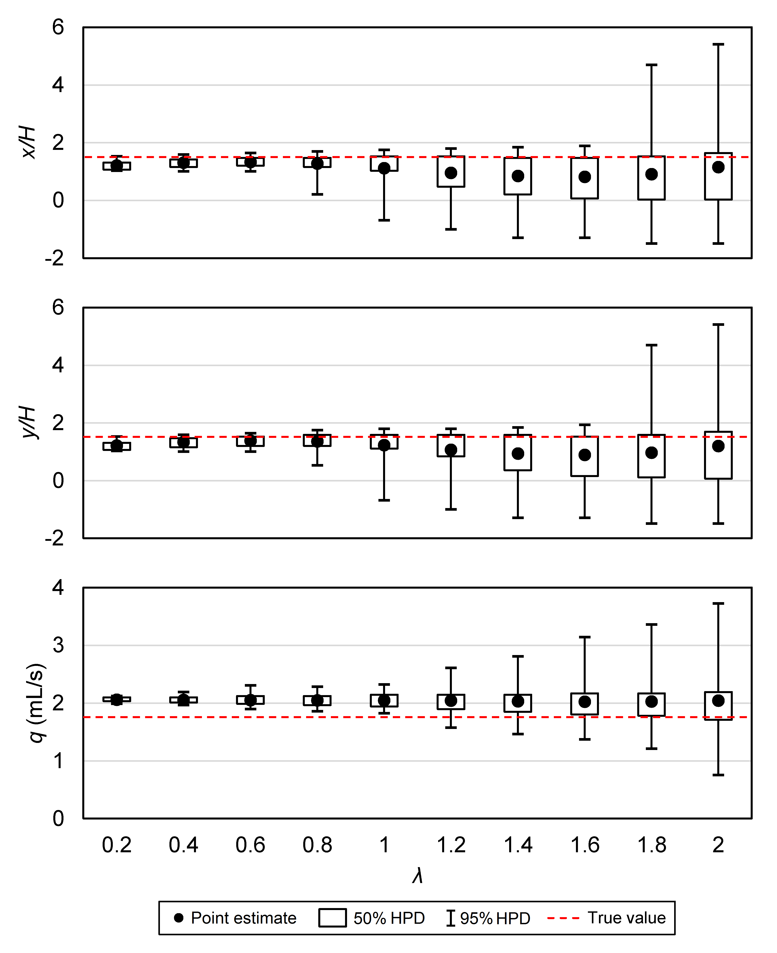

Fig. S2. Estimation results of source location (*x*- and *y*-coordinates)and emission strength *q* (mL/s) with different *λ* values in Case 2. Points denote the point estimates, i.e., posterior mean values, with boxes and whiskers representing the 50% and 95% highest posterior density intervals, respectively. True values are indicated by dashed lines.

In general, the value of $σ_{i}$ is positively correlated to the uncertainty (the 50% and 95% HPD intervals) of all estimated parameters. When λ is small, such as 0.2 and 0.4, the estimation results approximate the maximum a posteriori estimations, with the HPD intervals being too small to provide reasonable estimations of uncertainties. For λ over 0.4, the 50% HPD intervals of the source location cover the true location, yielding acceptable estimation quality. However, for λ larger than 1.4, the HPD intervals occupy the majority of the investigated region, too large to provide accurate estimation. In terms of the emission rate, its point estimation appears to be less sensitive to λ than that of the source location although its HPD intervals increase markedly with larger λ. In all, we consider λ = 1.0, as used in the manuscript, to be a reasonable choice.